Multiple-choice section

|  |  |  |  |  |  |  |  |  |
| --- | --- | --- | --- | --- | --- | --- | --- | --- |
| Question | 1 | 2 | 3 | 4 | 5 | 6 | 7 | 8 |
| Answer | A | C | B | A | D | B | D | D |

Question 1 [12.1]

A

 can be written as y = 5x – 5, which is linear.

Question 2 [12.1]

C

The horizontal asymptote is y = 6 and the vertical asymptote is x = -8.

Question 3 [12.1]

B

(x + 6)2 + (y – 4) = 9

r2 = 9 so r = 3

Centre is at (-6, 4)

Question 4 [12.2]

A

A The graph of  is a rectangular hyperbola.

B is the reflection of the rectangular hyperbola in the x-axis

C is a cubic

D is a parabola

Question 5 [12.3]

D



Question 6

B



Question 7 [12.4] [10A]

D

 =  = ≠

 =  = 

Question 8 [12.6] [10A]

D

= 

= (3-2)

= -2(3)

= -2

Multiple-choice total marks: 8

Short answer section

Question 9 6 marks [12.1]

In the term 5x6, x is the base, 5 is the coefficient and 6 is the power or index.

Question 10 6 marks [12.2]

(a) The centre of the circle (x – 2)2 + (y + 3)2 = 25 would have been moved 3 units to the left and 4 units up to obtain (x + 1)2 + (y – 1)2 = 9 and have its radius reduced by 2 units.

(b) The graph of y = 4x has been reflected in the y-axis, moved 5 units to the right and three units down.

(c) The graph of y = has been dilated by a factor of 2, reflected in the y-axis, moved 6 units to the left and moved 2 units up.

Question 11 10 marks [12.2]

|  |  |
| --- | --- |
| (a) (i) rectangular hyperbola  (ii) y =  + 3  (iii) For y = 0: 0 =  + 3 -3 =  -3(x + 1) = 1 -3x – 3 = 1 -3x = 4 x =  (iv) For x = 0: y = 4  (v)  Macintosh HD:Users:lizwaud:Desktop:PM10_2ed:eBook:Batch1_ChTests:Artwork_Chapter tests and exams:Artwork to be placed:newAW_Ch12:PM2e_10_EB_09_ATS_01.jpg | (b) (i) Exponential graph  (ii) y = 2x + 3  (iii) x-intercept occurs when y = 0, however, this relationship has a limiting value (an asymptote at y = 3) and therefore the graph does not cut the x-axis. Hence no x-intercept exists.  (iv) y-intercept occurs where x = 0 y = 1 + 3 y = 4 (0, 4)  (v)  Macintosh HD:Users:lizwaud:Desktop:PM10_2ed:eBook:Batch1_ChTests:Artwork_Chapter tests and exams:Artwork to be placed:newAW_Ch12:PM2e_10_EB_09_ATS_02.jpg |

Question 12 1 mark [12.5] [10A]

(81) = 4 is equivalent to 34 = 81

Question 13 6 marks [12.5] [10A]

|  |  |  |
| --- | --- | --- |
| (a) (x) = 4 x = 34 = 81 | (b) (1000) = 3 1000 = x3 103 = x3  x = 10 | (c) 2 + 5 = 11 2 = 6  = 3 x = 33 = 27 |

Question 14 4 mark [12.3]

 ÷ 

=  × 

=  × 

=  ×    
=  or 

Question 15 3 mark [12.4] [10A]

 = 

= 

= 

= 

Question 16 3 mark [12.4] [10A]

4 × 5

= 20

= 20

= 20

Question 17 6 marks [12.6] [10A]

|  |  |  |
| --- | --- | --- |
| (a) (15 625) = 6 x6 = 15 625 So x = 5. | (b) logy (15 625) = 12  6(5) = 12 (5) = 2 5 = y2 y = | (c)  6(5) = 3 (5) =  5 =  = 5 z = 25 |

Short answer total marks: 43

Extended answer section

Question 18 9 marks [12.2]

(a), (b)

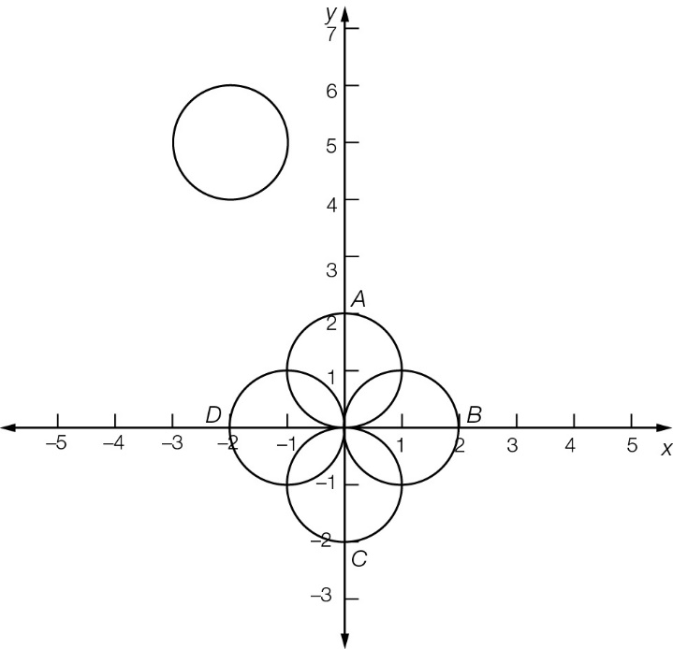

(c) Circle A translates 2 units left and 4 units up.  
Circle B translates 3 units left and 5 units up.   
Circle C translates 2 units left and 6 units up.   
Circle D translates 1 unit left and 5 units up.

Question 19 6 marks [12.2]

(a) From the general equation for an exponential y = ax – h + k.  
a = 3, h = -2, k = 1

(b) Yes, an asymptote exists at y = k y = 1

(c) For x = 0:  
y = 30+2 + 1  
y = 32 + 1  
y = 9 +1  
y = 10  
The y-intercept is correct at (0, 10)

(d) The basic exponential y = 3x has been moved 2 units to the left and 1 unit up.

Question 20 8 marks [12.2]

(a) 24 = 310k + 15  
9 = 310k  
310k = 32  
10k = 2  
k = 0.2

(b) When t = 0,  
T = 30 + 15  
= 1 + 15  
= 16 °C

(c) When ,  
T = 3(0.2 × 20) + 15  
= 96 °C  
Temperature increase  
= 96 – 16   
= 80 °C

(d) Points (0, 16), (10, 24), (20, 96)

Question 21 6 marks [12.1, 12.2]

(a) h = -4, k = 3

(b) 2 =  + 3  
-1 =   
a = -2

(c) Graph is reflected in the x-axis, dilated by a factor of 2 from the y-axis, translated 4 units to the left and 3 units up.

(d) 5 units right, 2 units up

Extended answer results: 29

TOTAL test results: 80